A Project I Proposal on
SmartResell – Your trusted Marketplace for Second-hand Mobile Phones
Submitted in partial fulfillment of the requirements for the degree of
Bachelor of Engineering in Software Engineering at Pokhara University

By
Bhawana KC
Kabita Adhikari
Prasamsha Tripathi



Department of Research and Development
GANDAKI COLLEGE OF ENGINEERING AND SCIENCE
Lamachaur, Kaski, Nepal
(May, 2025)

A Project I Proposal on
SmartResell – Your trusted Marketplace for Second-hand Mobile Phones
Submitted in partial fulfillment of the requirements for the degree of
Bachelor of Engineering in Software Engineering at Pokhara University

By
Bhawana KC
Kabita Adhikari
Prasamsha Tripathi

Supervisor
Er. Pratikshya Shrestha
Department of Research and Development
GANDAKI COLLEGE OF ENGINEERING AND SCIENCE
Lamachaur, Kaski, Nepal
(May, 2025)

APPROVAL CERTIFICATE
This project entitled "SmartResell – Your trusted Marketplace for Second-hand Mobile Phones" prepared and submitted by "Bhawana KC", "Kabita Adhikari", "Prasamsha Tripathi" under the supervision of "Er. Pratikshya Shrestha" in partial fulfillment of the requirements for the Degree of Bachelor of Engineering in Software Engineering has been examined and is recommended for approval and acceptance.

Date of Evaluation: May, 2025

……………………………………
Er. Pratikshya Shrestha
(Project Supervisor)

…………………………………
Er. Santosh Panth
Project Head
Research Management Committee
Gandaki College of Engineering and Science

ABSTRACT
SmartResell is a web-based marketplace designed to make buying and selling second-hand mobile phones easier, faster, and more reliable. Unlike existing platforms, SmartResell uses machine learning model to suggest fair prices for used phones based on real market data. This helps sellers avoid overpricing or underpricing their devices. The platform also includes features like direct communication between buyers and sellers, and a trust badge system to build user confidence. With these tools, SmartResell aims to improve the second-hand phone shopping experience by making it more transparent, efficient, and trustworthy.
Keywords: Marketplace, Machine Learning, Price Prediction, Fair-pricing, Communication, Trust Badge, Transparent, Efficient, Trustworthy

Table of Contents
APPROVAL CERTIFICATE iv
ABSTRACT v
Chapter 1 1
INTRODUCTION 1
1.1. Background 1
1.2. Problem Statement 1
1.3. Objective 1
1.4. Implication 2
Chapter 2 3
LITERATURE REVIEW 3
Chapter 3 6
TOOLS AND METHODOLOGY 6
3.1. Required Tools 6
3.2. Methodology 7
3.2.1. Use Case Diagram 7
3.2.2. System Sequence Diagram 14
3.2.3. Entity Relationship Diagram 17
3.3. Approaches Used 18
3.3.1 Why Waterfall Model? 18
3.3.2. Phase 18
3.4. Proposed Methodology 20
3.4.1. Steps 20
3.5 Machine Learning Algorithm Used 22
3.5.1 Why Linear Regression? 22
Chapter 4 23
EXCEPTED OUTCOMES 23
TIMELINE 24
5.1 Timeline Chart 24
Bibliography 25
APPENDIX: WIREFRAMES 26

List of Figures
Figure 3.2.1.1 Use Case Diagram 7
Figure 3.2.2.1 System Sequence Diagram for Seller 13
Figure 3.2.2.2 System Sequence Diagram for Buyer 14
Figure 3.2.2.3 System Sequence Diagram for Admin 15
Figure 3.2.3.1 Entity Relationship Diagram 16
Figure 3.3.2.1 Waterfall Model 18
Figure 3.4.1 Proposed Methodology 19
Figure 5.1.1 Gantt Chart 23

Chapter 1

INTRODUCTION

1.1. Background
The second-hand mobile phone market has grown with increasing demand for affordable smartphones. However, platforms like HamroBazar and Swappa lack intelligent pricing tools and effective communication, often leading to delays or failed transactions. SmartResell proposes a web-based platform where users can buy and sell second-hand mobile phones. It will feature an AI-powered price prediction system to guide sellers in setting fair prices, improve communication between buyers and sellers, and track interactions to enhance engagement and analytics.

1.2. Problem Statement
Existing second-hand mobile phone marketplaces face several problems that make buying and selling difficult. They do not provide smart pricing tools based on real market data, so sellers often set prices too high or too low, which stops many sales from happening. Also, these platforms do not track transactions or encourage buyers and sellers to complete deals within the system, which reduces transparency and makes it hard to build trust. Additionally, communication between buyers and sellers is often slow or unclear, causing delays and sometimes failed deals. These issues make the whole process frustrating and less reliable.

1.3. Objective
- To develop a web interface with a price prediction system that helps sellers set fair prices and enables buyers to find reasonably priced second-hand mobile phones.

1.4. Implication
Sellers will be able to list their phones at fair and competitive market prices with confidence. Buyers will benefit from transparent pricing and trustworthy listings powered by AI. Enhanced communication tools will improve the speed and success of transactions. Tracking user activity will improve transparency and allow for better user trust and dispute resolution. The platform can use engagement data to offer personalized experiences and improve services. SmartResell will gain a competitive edge by addressing major limitations of existing marketplaces.

Chapter 2

LITERATURE REVIEW
Various websites have already been developed in the market to offer users a platform to list Second-hand mobile phone, browse listings, and communicate with potential buyers or sellers. Apart from these established websites our goal is to improve the experience for both buyers and sellers by integrating AI-powered price prediction system to guide sellers in setting fair prices, improve communication between buyers and sellers, and track interactions to enhance engagement and analytics. Those web applications that are similar with our project are:

HamroBazar is one of Nepal’s most popular online marketplaces for buying and selling secondhand goods such as mobile phones, electronics, vehicles, and real estate. Founded in 2005, it allows users to post free listings for both new and used items, helping connect local buyers and sellers directly. The platform’s Android app has made browsing and listing more convenient, although some users have reported occasional technical problems like slow loading times and performance issues. In 2024, HamroBazar introduced a “Buy Now, Pay Later” (BNPL) service in partnership with Foneloan, which has made it easier for buyers to afford products by spreading payments over time. Despite its popularity, HamroBazar still faces challenges such as the lack of AI-powered pricing tools, which means prices are set manually by sellers. Additionally, the platform does not have integrated communication features, so buyers and sellers often rely on external apps like WhatsApp for negotiations. [1].

Swappa is a well-known online marketplace from the United States where people buy and sell used electronics like mobile phones, laptops, tablets, and other gadgets. What makes Swappa different from many other sites is that every product is carefully checked by the Swappa team before it is allowed to be sold. This means that only real, working, and good-quality items are listed on the platform. Because of this careful review, many buyers and sellers trust Swappa for safe and honest transactions. This process helps prevent people from getting fake, damaged, or poor-quality products. Swappa’s focus on safety and quality makes it a reliable place for buying and selling used electronics. [2].

Cashify is a popular company in India that helps people sell their old electronic devices easily. These devices include smartphones, laptops, tablets, and smartwatches. The company started in 2009 and later changed its name or style in 2013 to become more known. What makes Cashify special is that it works as a reverse marketplace. This means instead of buying new products, it helps users sell their used gadgets online. When someone wants to sell, they can get instant payment through cash, bank transfer, or UPI, making the process quick and Convenient. After collecting these used devices, Cashify carefully checks and repairs them to make sure they work well. Then, the company sells these devices again as certified pre-owned products. This way, people who want to buy gadgets can get good quality items at a lower price than new ones. Cashify helps reduce electronic waste by giving old gadgets a second life, which is also good for the environment. Overall, it’s a simple, safe, and fast way for people to sell and buy used electronics. [3].

OLX India is a well-known online platform where people can buy and sell used items easily. Whether it’s electronics like phones and laptops, cars, furniture, or other household things, OLX lets users list their products for free. This means anyone can put up what they want to sell without paying any charges. Buyers and sellers can then connect directly through the OLX app or website, making the whole process simple and fast. The platform is designed to be easy to use, so even people who aren’t very familiar with technology can navigate it without problems. OLX has millions of users from big cities as well as smaller towns all over India, which helps in finding buyers or sellers nearby quickly. Because of its large reach and simple process, OLX has become one of the most popular choices for people looking to buy or sell secondhand items. It helps many people save money by buying used goods and also helps sellers find buyers without much hassle. [4].

Back Market provides a structured platform for reselling used devices, ensuring quality control through third-party refurbishes and offering warranties to customers. The pricing on such platforms is influenced by various factors such as the device's brand, model, age, cosmetic condition, technical specifications, and the refurbishes quality grade. However, despite these efforts, consumers and sellers alike often face challenges in assessing whether a second-hand phone is priced fairly. This challenge underscores the importance of predictive models that can estimate a phone’s resale value based on its features and condition. Similar to our concept but additionally our concept provides feature of direct communication between buyer and seller. [5].

bank. The study highlights the importance of
technology in blood banks and how a
software system can help streamline
processes and reduce errors. The paper also
discusses the challenges faced by blood
banks, such as the shortage of blood supply
and the need for proper testing and
screening of donors.
bank. The study highlights the importance of
technology in blood banks and how a
software system can help streamline
processes and reduce errors. The paper also
discusses the challenges faced by blood
banks, such as the shortage of blood supply
and the need for proper testing and
screening of donors.
bank. The study highlights the importance of
technology in blood banks and how a
software system can help streamline
processes and reduce errors. The paper also
discusses the challenges faced by blood
banks, such as the shortage of blood supply
and the need for proper testing and
screening of donors.

Chapter 3

TOOLS AND METHODOLOGY

3.1. Required Tools
The following tools are used for development of this project:
- For frontend:
  - HTML, CSS, JavaScript, Bootstrap
- For backend:
  - Django
- Database:
  - MySQL
- For UML diagrams and wireframes:
  - Draw.io
- Machine Learning:
  - Python (Scikit-learn)
- Web Scraping:
  - BeautifulSoup
- For Gantt chart:
  - MS-Excel
- For version control and collaboration:
  - Git and GitHub
- For coding:
  - Visual Studio Code

3.2. Methodology

3.2.1. Use Case Diagram
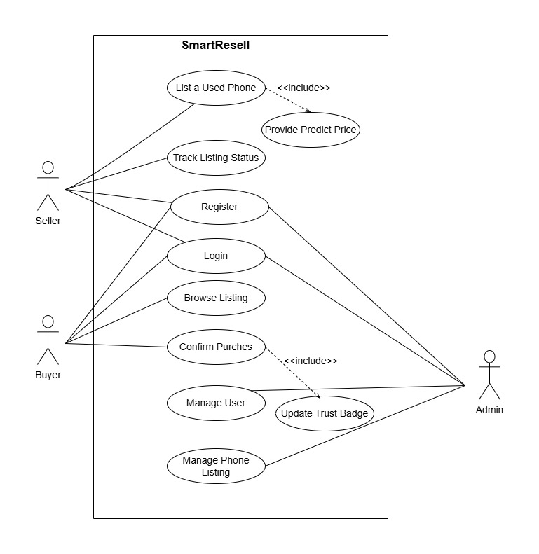
Figure 3.2.1.1 Use Case Diagram

Use Case UC1: Register
Primary Actor: Seller, Buyer and Admin
Stockholders and Interests:
- Owner (Seller/Buyer): Wants to create a new account.
- System: Store user information and update the database.
Pre-condition: User must have a valid e-mail address.
Post-condition: The user is registered.

Use Case UC2: Login
Primary Actor: Seller, Buyer and Admin
Stockholders and Interests:
- Owner (Seller, Buyer and Admin): Wants to login to the system.
- System: Verifies the entered credentials.
Pre-condition: The user must have an account.
Post-condition: The user is logged in.

Use Case UC3: List a Used Phone
Primary Actor: Seller
Stockholders and Interests:
- Owner (Seller): Wants to list the phone easily with good price guidance to sell it quickly.
- System: Needs accurate phone details to generate price predictions and maintain quality listings.
Pre-condition: Seller is logged in and has phone details ready to submit.
Post-condition: Listing is created, price prediction is generated, and the listing is sent for admin approval.
Use Case UC4: Provide Predicted Price
Primary Actor: System
Stockholders and Interests:
- Owner (Seller): Wants a reliable, market-based price estimate for their phone.
- System: Needs to provide accurate pricing to build trust and help users price their listings competitively.
Pre-condition: Phone details are submitted by the seller during listing.
Post-condition: AI returns a price suggestion, which the seller can view and use when setting their listing price.

Use Case UC5: Track Listing Status
Primary Actor: Seller
Stockholders and Interests:
- Owner (Seller): Wants to see if their phone listing is active, pending approval, or sold.
- System: Needs to keep listing statuses updated and accurate for transparency
Pre-condition: Seller has at least one active or pending phone listing.
Post-condition: Seller has at least one active or pending phone listing. Seller can view current status of each listing anytime (e.g., approved, rejected, sold).

Use Case UC6: Browse Listing
Primary Actor: Buyer
Stockholders and Interests:
- Owner (Buyer): Wants to easily find phones that meet their preferences.
- System: Provides an efficient search and filtering tool to improve user experience and increase sales.
Pre-condition: Buyer is logged in or browsing the platform with access to active listings.
Post-condition: Buyer views filtered listings matching their criteria and can proceed to view details or contact sellers.

Use Case UC7: Confirm Purchas
Primary Actor: Buyer
Stockholders and Interests:
- Owner (Buyer): Wants to confirm that they received the phone and finalize the purchase.
- Owner (Seller): Wants confirmation that the sale is completed.
- System: Updates records and notifies all parties of transaction completion
Pre-condition: Buyer is logged in or browsing the platform with access to active listings.
Post-condition: Buyer views filtered listings matching their criteria and can proceed to view details or contact sellers.

Use Case UC8: Update Trust Badge
Primary Actor: Admin
Stockholders and Interests:
- Owner (Admin): Wants to award trust badges to reliable users to improve platform credibility.
- Owner (Users): Want to earn badges as proof of trustworthiness.
- System: Tracks user behavior and badges to promote trust.
Pre-condition: Users have history and reputation data available.
Post-condition: Trust badges assigned or revoked based on user activity and admin review.

Use Case UC9: Manage User
Primary Actor: Admin
Stockholders and Interests:
  - Owner (Admin): Needs to add, remove, or update user accounts to maintain platform integrity.
  - System: Enforces rules and maintains user database accuracy.
  - Owner (Users): Expect fair and transparent management of accounts.
Pre-condition: Admin is logged in with appropriate privileges
Post-condition: User accounts are updated, suspended, or deleted as needed; system logs changes for auditing.

Use Case UC10: Manage Phone Listing
Primary Actor: Admin
Stockholders and Interests:
  - Owner (Admin): Wants to keep the platform trustworthy by approving only quality listings.
  - System: Maintains listing quality and platform reputation.
  - Owner (Seller): Wants fast approval for quick listing
Pre-condition: Seller has submitted a new phone listing for approval.
Post-condition: Listing is either approved and published or rejected with feedback sent to the seller.

.

3.2.2. System Sequence Diagram

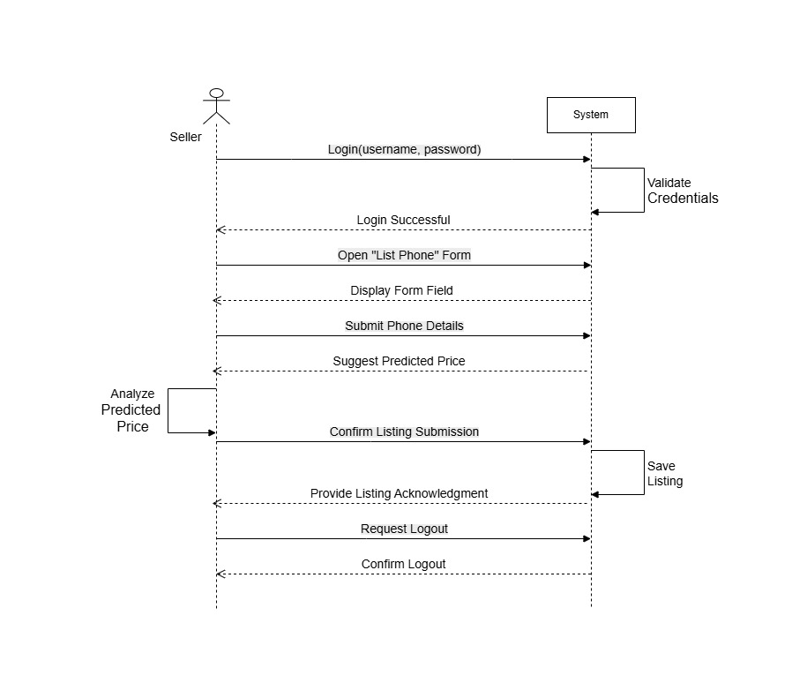
Figure 3.2.2.1 System Sequence Diagram for Seller

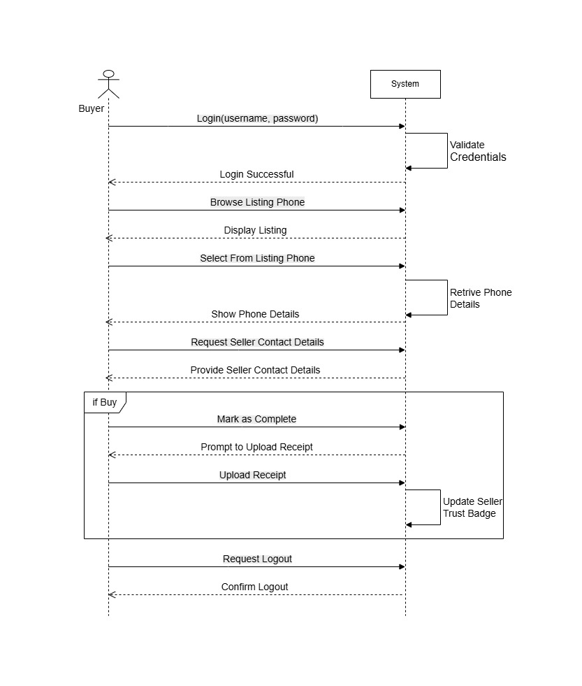
Figure 3.2.2.2 System Sequence Diagram for Buyer

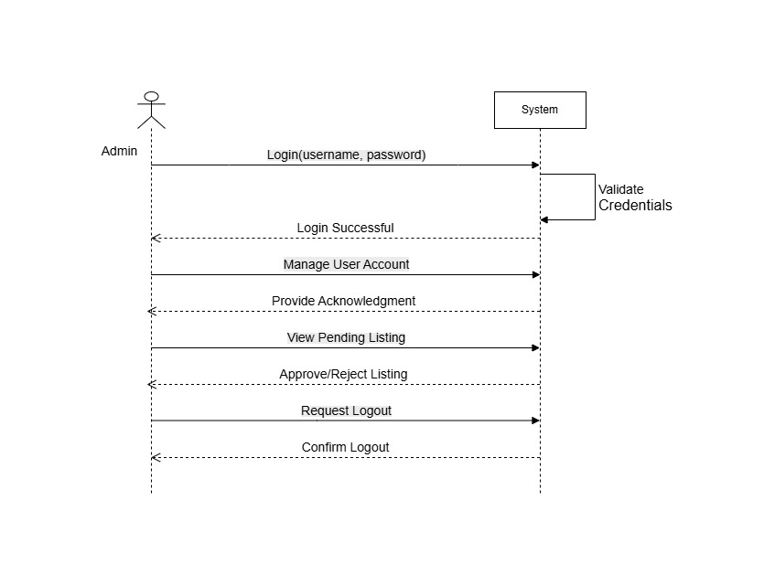
Figure 3.2.2.3 System Sequence Diagram for Admin

3.2.3. Entity Relationship Diagram

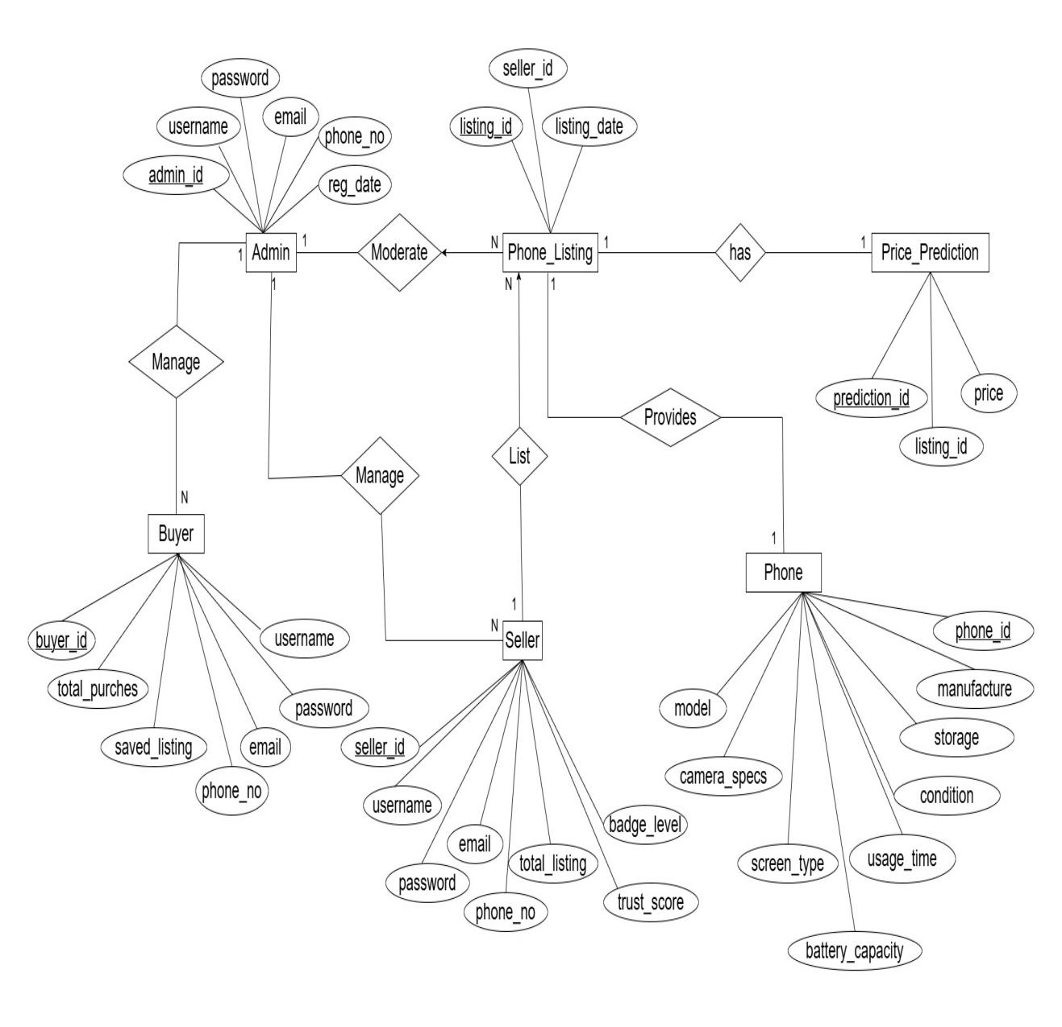
Figure 3.2.3.1 Entity Relationship Diagram

3.3. Approaches Used

3.3.1 Why Waterfall Model?
The “Waterfall Model” can be effective for developing our system due to its structured approach. This model works well because we already know what the system should do. It helps us stay organized and finish each part before moving to the next one. It is a good method for this project where the plan doesn’t change much.

3.3.2. Phase
- Requirement Analysis:
This phase involved all the important features needed for the SmartResell website, like buying/selling phones, smart price suggestions and admin tools.

- System Design:
In this phase system architecture document detailing the overall structure of the system and make detailed design documents for each module, including use case diagram, system sequence diagram and entity-relationship diagram.

- Coding:
In this phase, development of the SmartResell website will begin based on the design plan. The frontend developers work on the user interface for buyers, sellers, and admins, making sure it looks good and is easy to use. The backend developers create the system's logic, connect it to the database, and build APIs. At the same time, the machine learning team trains the price prediction model using real market data. Each part of the system is built separately and then combined to work together as one complete website. Everything is coded carefully to match the project goals.

- Testing:
This phase verifies and validate the implemented system to ensure it meets the specified requirements and functions correctly.

- Deployment:
In this phase, deploy the tested and validated system into a production environment.

- Maintenance:
In this phase, the system’s performance is monitored closely, and any reported problems or bugs will fix. Updates and patches are made to improve how the system works and to meet new needs. User feedback is collected regularly, and the system is reviewed often to find ways to make it better.

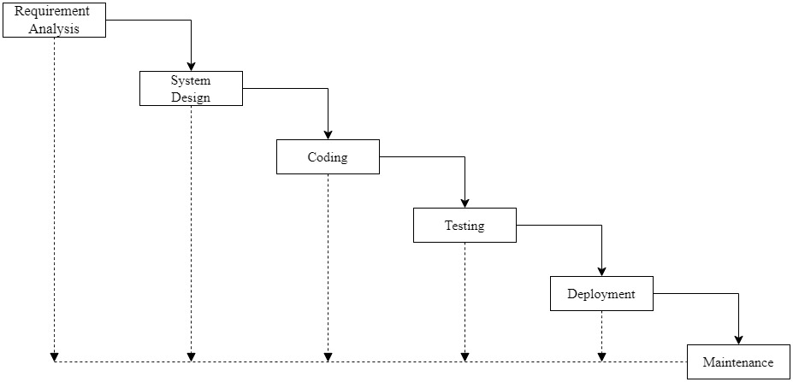
Figure 3.3.2.1 Waterfall Model

3.4. Proposed Methodology
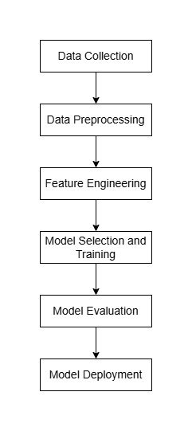
Figure 3.4.1 Proposed Methodology

3.4.1. Steps
1. Data Collection:
For the development of the SmartResell platform, data on second-hand mobile phones will be collected primarily from Hamrobazar, a well-known online marketplace. This will be done using web scraping techniques to automatically extract relevant details such as brand, model, storage capacity, RAM, phone condition, and price.

2. Data Preprocessing:
Once collecting the raw data, then need to clean and prepare it. This means removing any incorrect or missing entries and turning words (like "Good" or "Fair" condition) into numbers that the computer can understand.

3. Feature Engineering:
In this step, the new useful data columns (called features) are creates from the existing data to help the model make better predictions.

4. Model Selection and Training:
In this phase, the model is train using Linear Regression Machine Learning Algorithm, which tries to draw a straight line that best fits the relationship between the phone features and its price. We use most of the data (about 80%) to teach the model and keep some of it aside to test if it learned correctly.

5. Model Evaluation:
This phase measure how well the model predicts unseen data using key metrices like Accuracy, Precision, F1 Score, Mean Absolute Error, Root Mean Square Error and so on.

6. Model Deployment:
In this phase, the model is connect with the SmartResell platform through the small service called an API. When someone lists a phone for sale, the website sends the phone details to the API, and the model suggest price for that listed phone.

3.5 Machine Learning Algorithm Used
For predicting the fair market price of second-hand mobile phones, the project will use the Linear Regression algorithm. This algorithm will be selected because it is simple to implement and effective for solving regression problems where the target variable is a continuous numeric value (the selling price of a phone).

3.5.1 Why Linear Regression?
Linear Regression will be chosen due to the following reasons:
- It will provide a clear and understandable relationship between phone features (such as brand, model, storage, RAM, and condition) and the predicted price.
- It will help understand how different features like brand, model, RAM, storage, condition, and age of the phone affect its resale value.
- It will provide sellers with fair and data-driven price suggestions, improving trust and transparency on the platform.
- It will require less data and will still perform well in early-stage development.

Chapter 4

EXCEPTED OUTCOMES

The SmartResell platform will deliver a fully functional and responsive website that works smoothly on all devices, including phones, tablets, and computers, allowing users to easily buy or sell second-hand mobile phones. It will include a smart price prediction tool powered by real market data to help sellers set fair and accurate prices for their devices. To build trust among users, the platform will confirm completed transactions, keep detailed records, and assign trust badges to reliable sellers. A built-in messaging system will enable direct communication between buyers and sellers, making the process faster and reducing misunderstandings. Additionally, administrators will have access to an advanced dashboard with tools and reports to monitor site performance, user activity, and market trends, helping to guide future improvements and ensure the platform runs efficiently.

TIMELINE

5.1 Timeline Chart

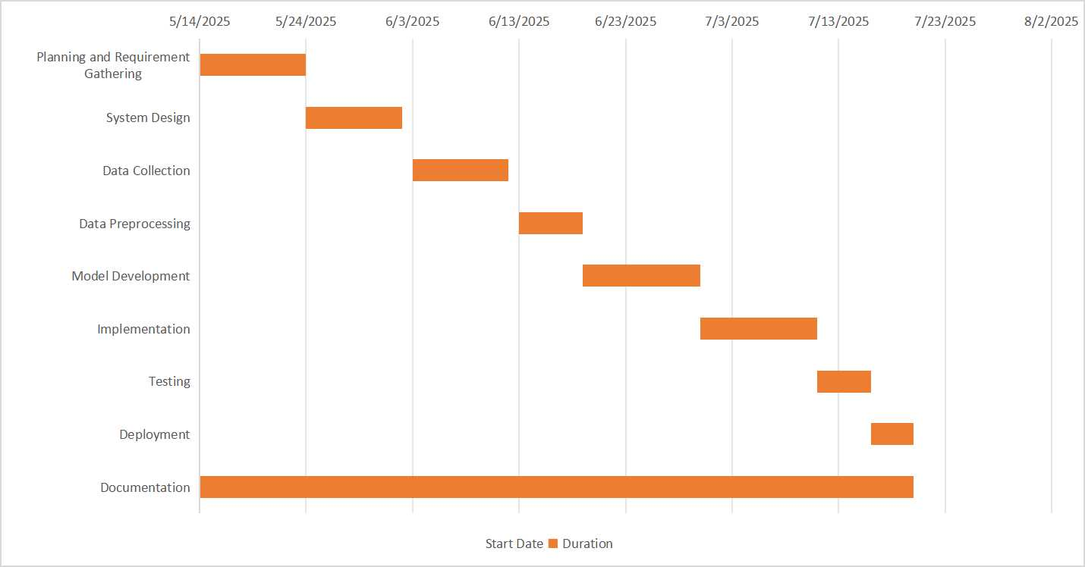
Figure 5.1.1 Gantt Chart

Bibliography

[1] | "Hamrobazar - Nepal's Online Marketplace for Shopping," 2005. [Online]. Available: https://hamrobazaar.com/.
[2] | B. Edwards, "Swappa - Buy & Sell - Phones, Laptops, Sneakers, & More," 2010. [Online]. Available: https://swappa.com/.
[3] | A. S. N. K. Mandeep Manocha, "Cashify: Sell/Buy Old and Used Mobile Phones Online in India," 2009. [Online]. Available: https://www.cashify.in/ .
[4] | F. G. Alec Oxenford, "OLX (Online Exchange)," 2006. [Online]. Available: https://www.olx.in/.
[5] | Q. L. B. V. V. Thibaud Hug de Larauze, "Back Market: Refurbished tech that's better for the planet," 2014. [Online]. Available: https://www.backmarket.com/en-us.

APPENDIX: WIREFRAMES

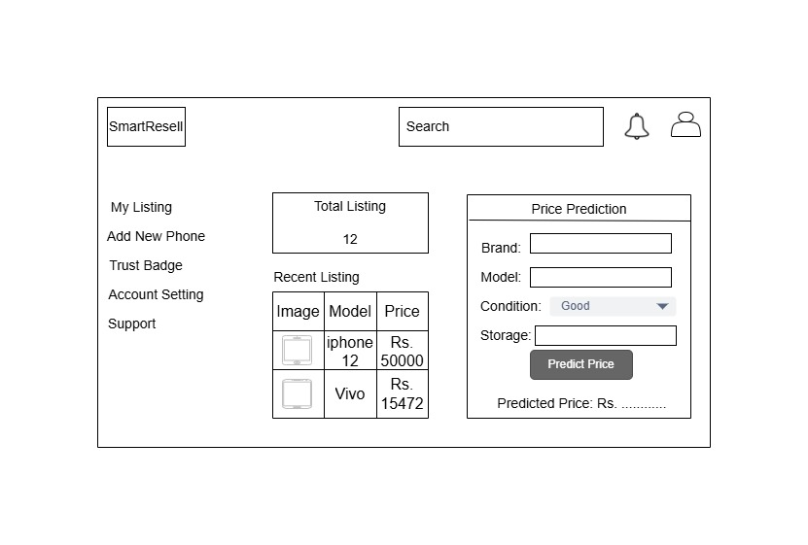
Appendix 1 Seller Dashboard Wireframe

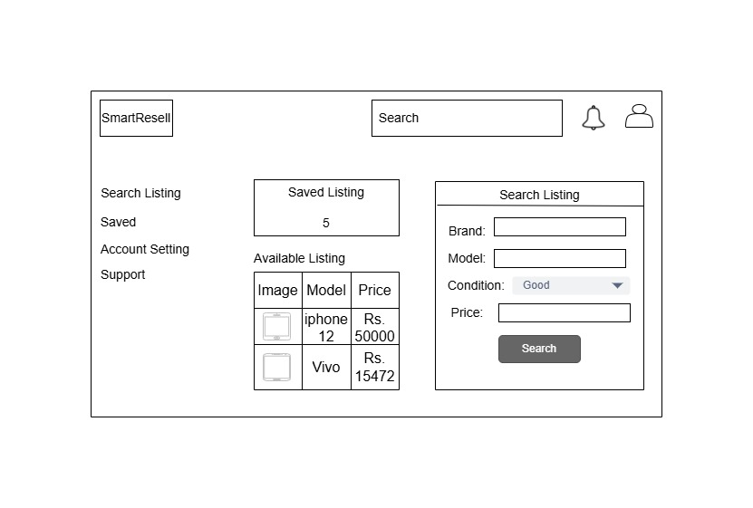
Appendix 2 Buyer Dashboard Wireframe

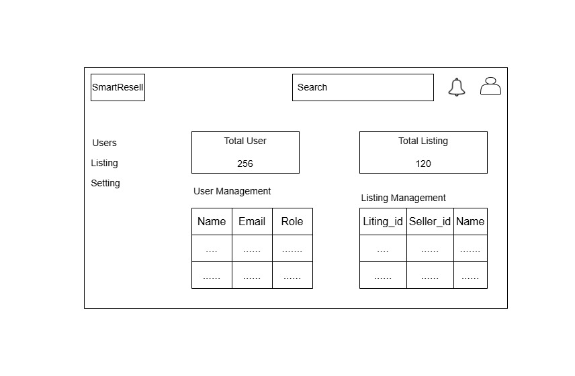
Appendix 3 Admin Dashboard Wireframe

